  Inspiring All to Excellence |  |  | 

Wilnecote Junior Academy

R.E. Disciplinary Skills and Knowledge Progression

Document Control

Policy Title | R.E. Disciplinary Skills and Knowledge Progression
Effective Date | June 2023
Policy Owner | Wilnecote Junior Academy
Policy Approver | Fierte Multi Academy Trust

Version Control

Version | Date | Amended by | Comments

Section | Changes Made

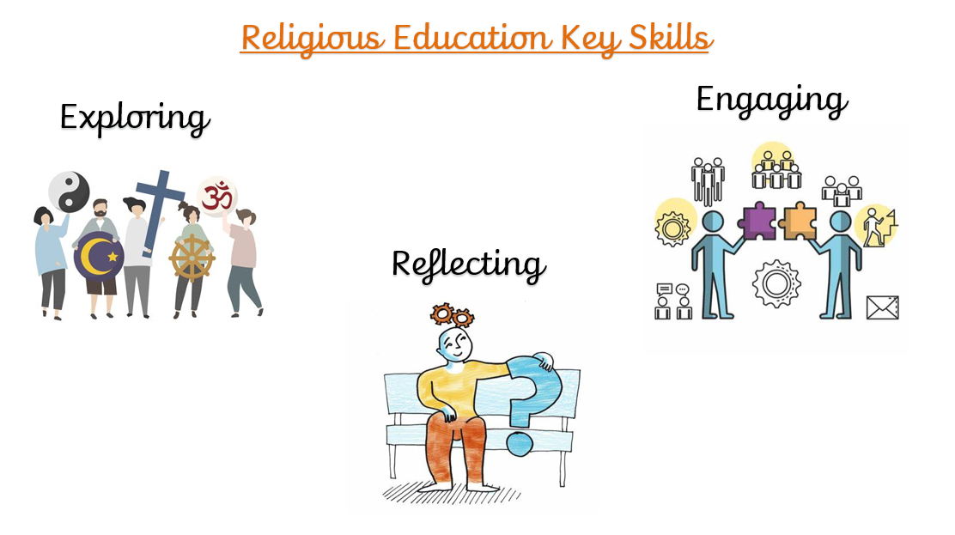
RE | Exploring | Engaging | Reflecting
EYFS | Pupils talk about past and present events in their own lives and in the lives of family members. They talk about similarities and differences in relation to themselves, places, objects, materials and living things including faith buildings e.g., the church or the mosque. | Pupils can talk about the features of their own immediate environment and how environments might vary from one another and what makes them special and unique. They enjoy learning about the diverse nature of the world about them. | Pupils can talk about how children do not always enjoy the same things and are sensitive to this. They can talk about similarities and differences between themselves and others, and among families, communities, and traditions. They can show how important it is to be part of a community.
Year 1 | Pupils use words and phrases to recognise and name features of religious life and practice valued by believers. They can recall religious stories and recognise symbols and other verbal and visual forms of religious expression which have meaning for believers. | Pupils can talk about the experiences of the world around them, stating what us of value and concern to themselves and others. They use stories to identify ways in which people are special and unique. | Pupils can demonstrate awareness that there are many religious traditions/faith communities and that some people do not follow a recognised faith or belief system or identify as being religious.
Year 2 | Pupils use words and phrases to identify some features of religious life and practices valued by believers. Pupils retell religious stories and suggest meanings for religious actions and symbols. They identify how religion is expressed in different ways. | Pupils can recognise that some questions cause people to wonder and are difficult to answer. They can share ideas about right and wrong. | Pupils can name more than one religious tradition or faith community and can talk about some of the distinctive features of each religious tradition/faith community. They know that some people do not identify as being religious.
Year 3 | Pupils use a developing vocabulary to describe some key features of religions, recognising similarities and differences. They make links between beliefs, practices, and sources, including religious stories and sacred texts. They begin to identify the impact religion has on believers’ lives. They describe some forms of religious expression. | Pupils ask important questions about values, commitments, and beliefs, making links between their own and others’ responses, attitudes and behaviour. | Pupils can identify and distinguish between the faiths and world views being explored and can express some awareness of their identify within or outside these faiths. They understand the importance and reality of existing in a plural context. They know that some people do not identify as being religious.
Year 4 | Pupils use a developing vocabulary to describe and show understanding of religious sources, practices, beliefs, ideas and experiences. They make links between them and describe some similarities and differences between and within religions. They describe the impact of religion on people’s lives. They explore and explain meanings for a range of forms of religious expression and non-religious expression. | Pupils raise and suggest answers to fundamental questions of identity, belonging, meaning, purpose, truth, values, and commitments, recognising the implications and consequences of making moral choices. | They apply their ideas about identity and commitment in a diverse world to their own and other people’s lives. They describe what inspires and influences themselves and others, especially their commitments, values, and choices. They can recognise in themselves and others some reactions to living alongside others who have a different faith or stance. They can explain why some people do not identify as being religious.
Year 5 | Pupils use an increasingly wide vocabulary to explain the impact of religious beliefs and a non-religious life stance on individuals and communities. They show a developing insight into why people belong to religions. They demonstrate that similarities and differences illustrate distinctive beliefs within and between religions. They suggest possible reasons for this and explain how religious sources are used to provide answers to ethical issues. | Pupils ask, and suggest answers to fundamental questions of identity, belonging, meaning, purpose and truth, values, and commitments, relating them to their own and others’ lives and making clear connections between personal viewpoints and action. | Pupils explain what inspires and influences them, expressing their own and others’ views on the opportunities and challenges of commitment in a diverse world. They identify the consequences for themselves and for others of holding particular beliefs and values.
Year 6 | Pupils use an increasingly rich vocabulary to give informed accounts of religions and beliefs. They interpret sources and arguments, explaining the reasons that are used in different ways by different traditions to provide answers for ethical issues. They interpret the significance of different forms of religious, spiritual, and moral expression. They interpret sources and arguments regarding world views/issues. | Pupils use reasoning and examples to explore the relationship between beliefs, teachings, and world issues. They express insights into their own and others’ views on fundamental questions of identify and belonging, meaning purpose and perceived truth. | Focusing on values and commitments pupils consider their own response to the opportunities and challenges of living in a diverse world whilst considering the views and experiences of others. They can talk about examples of religious cooperation and why this is sometimes difficult.

