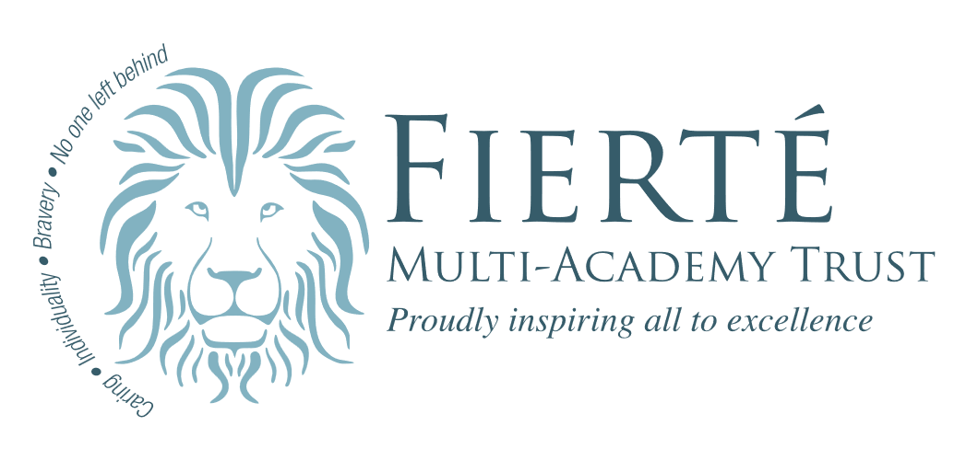

Wilnecote Junior Academy

Personal, Social, Health and Economic (PSHE) Education, including Relationships and Sex Education Policy

Document and Version Control
Document Title | Personal, Social, Health and Economic (PSHE) Education, including Relationships and Sex Education Policy
Effective Date | September 2026
Policy Owner | Cheryl Harridence & Phil Bartholomew
Policy Approver | Matthew Fletcher (Chair of Governors)

Version | Date | Amended by | Comments
I | April 2026 | PSHE Policy Working Group

Section | Changes Made
Contents
Personal, Social, Health and Economic (PSHE) Education, including Relationships and Sex Education Policy 1
Document and Version Control 2
Introduction 4
What is PSHE? 4
Why is PSHE Important? 5
Curriculum Planning 5
Pupil Voice and a Needs-Led Curriculum 6
The Curriculum 7
Resources 8
Sex Education 8
Teaching and Learning 8
External Providers 9
Establishing a Safe Learning Environment 9
Responding to Questions and Managing Disclosures 10
Accessibility of the Curriculum 10
Staff Training 11
Assessment 12
Evaluation 12
Engaging Parents and Carers 12
Right to Withdraw 13
Policy Links 13
Creation, Consultation, Monitoring and Review of Policy 14
More Information 14

Introduction
This policy explains how Fierte Multi-Academy Trust teaches Personal, Social, Health and Economic (PSHE) education. It also includes Relationships Education and Health Education, which all schools must teach.
This policy has been written using information from the Department for Education’s (DfE) Relationships Education, Relationships and Sex Education (RSE) and Health Education guidance (2025) and other relevant guidance document and statutory requirements.
Since 2019, the Relationships Education, Relationships and Sex Education and Health Education (England) Regulations made under sections 34 and 35 of the Children and Social Work Act 2017, says that by law all schools must teach children about relationships and health.
PSHE helps us keep children safe. It also helps prepare them for life as they grow up. We teach PSHE in a way that suits the age and stage of our pupils.
With the support of the Pan-Staffordshire PSHE Education Service we have created this policy to show what we teach in PSHE and why it is important.

What is PSHE?
PSHE is the curriculum subject designed to help children and young people stay healthy, safe and prepared for life and work. There are parts of PSHE that the school has to teach, this is outlined in the RSHE guidance, and children and young people learn, in an age-appropriate way, to:
- Recognise and manage their feelings
- Build healthy friendships
- Stay safe online and in their communities
- Make positive choices
- Look after their body and mind
- Respect other people
- Describe parts of the body and how it changes
Other elements are not statutory, but we believe are important for children to learn about, this includes content such as economic wellbeing and career-related learning.
PSHE education helps children to feel confident, solve problems and know what to do if something worries them. It teaches them to make safe, kind and sensible choices as they grow up.

Why is PSHE Important?
Our PSHE programme also links to our Trust values of We Care, We are Brave, We leave no-one behind, We celebrate individuality. Through our PSHE programme we enable our children to develop these life-long values.
This diagram shows the visions and aims of our PSHE programme across our Trust.
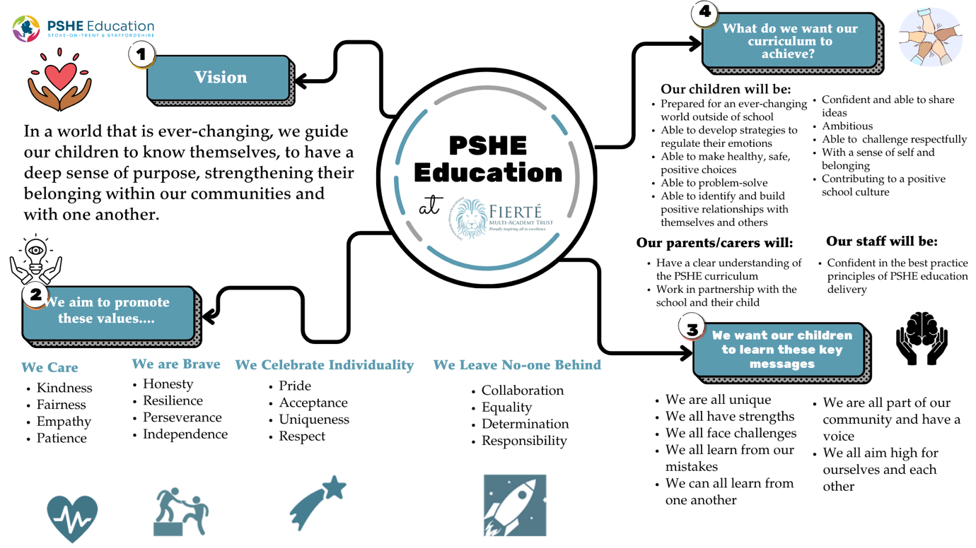
We know parents and carers play an important role in teaching their children about relationships, growing up and keeping safe. We also know that some parents and carers may not feel confident talking about these topics. Our PSHE lessons help make sure all children get the information they need to stay safe and make healthy, positive choices

Curriculum Planning
We deliver a well-planned PSHE programme based on a spiral curriculum, where key themes are revisited and built upon over time. This is outlined in our long term curriculum plan which can be found on our website: Heathfields Infant and Wilnecote Junior Academies - PSHE & RSE This approach ensures that pupils deepen their knowledge, develop the skills and values they need to thrive both in school and beyond. Our curriculum is designed to:
- Provide our children with the knowledge, confidence and self-awareness to make informed, positive choices and decisions to keep themselves and others safe.
- Develop knowledge and understanding of positive, healthy and respectful relationships.
- Promote understanding and respect for a range of families, relationships, values, beliefs and faith perspectives.
- Help our children reflect on and make sense of their personal and social experiences.
- Promote positive attitudes towards maintaining good physical and mental health through safe and healthy lifestyles.
- Foster respectful and caring relationships with others.
- Encourage and care for the environment.
- Support our children in understanding, managing and regulating their emotions, building resilience, and becoming independent, curious problem-solvers.
- Support our children to use the internet and digital technologies safely and responsibly.
- Develop pupils understanding of reproduction and birth taught within the context of loving and caring relationships.
- Ensure they know when, how and where to access appropriate support.
We know there is a proven link between pupils' health and wellbeing, and their academic progress. Crucial skills and positive attitudes developed through comprehensive PSHE education are critical to ensuring children are effective learners.
Our PSHE curriculum is based on the needs of the children in the school with clear learning outcomes appropriate to their age, development, ability and level of maturity. PSHE will be firmly embedded within our broader curriculum, including science and PE, in addition to more focused learning in PSHE sessions, circle-time and assemblies, class buddies, House Teams, School Council, Eco council.
The DfE has set out guiding principles for effective RSE delivery. These principles are utilised to inform our programme and are reflected within this policy. These are:
- Engagement with pupils
- Engagement and transparency with parents/carers
- Positivity
- Careful sequencing
- Relevant and responsive
- Skilled delivery of participatory education
- Whole school approach.

Pupil Voice and a Needs-Led Curriculum
Listening to the voices of our children is an important part of our PSHE programme. We provide opportunities for pupils to share their views and experiences of PSHE through class discussions, feedback activities, pupil survey, school council or similar. Our children are encouraged to share their views, and these are listened to, valued and respected.
Information gathered from pupil voice, alongside other sources of data, including safeguarding, behaviour, local data and intelligence, is used to inform curriculum planning and teaching approaches. This helps ensure our PSHE curriculum is relevant and responsive to our local context and the needs of our children.

The Curriculum
PSHE is taught to every year group (Year 3-6) throughout the school. The curriculum is age-appropriate and progressive, building on the children’s knowledge, and skills year on year. Our content and delivery support children to develop a positive view of healthy relationships, being healthy and keeping safe. We work to objectives in each year group that support the outcomes outlined in the DfE’s RSHE guidance.
Learning outcomes for each year group can be found on our website: Heathfields Infant and Wilnecote Junior Academies - PSHE & RSE
Some elements of PSHE are delivered through the National Curriculum for Science:
- Year 5
  - Pupils should be taught to:
    - Describe the changes as humans develop to old age
    - Below is a list of topics covered by our PSHE programme, in line with government guidance:
- Families and people who care for me
- Caring friendships
- Respectful, kind relationships
- Online safety and awareness
- Being safe
- General wellbeing
- Wellbeing online
- Physical health and fitness
- Healthy eating
- Drugs, alcohol, tobacco and vaping
- Health protection and prevention
- Personal safety
- Basic First Aid
- Developing bodies.
As part of PSHE, children will be taught scientific names for genitals in an age-appropriate and sensitive way. The words we use are breasts, genitals, penis, puberty, testicles/testes, cervix, egg/ovum, erection, labia, bladder, bleeding, ejaculation, fallopian tube, menstruation/period.
You can see when these terms are introduced on our website: Heathfields Infant and Wilnecote Junior Academies - PSHE & RSE
As outlined in the RSHE guidance, it is important that our curriculum is relevant and responsive to the needs of our children. Therefore, the PSHE Lead constantly reviews the curriculum to ensure it addresses current safeguarding needs and trends in order to keep children safe. This may mean that we need to add content to the programme. Where this is the case, parents and carers will be informed in advance and be able to request access to the resource that will be used.

Resources
As with other subjects, the breadth of the PSHE curriculum means that we use a wide variety of age-appropriate activities, books and resources. These are provided through our schemes of work, and other quality-assured reputable sources. All resources are reviewed prior to teaching to ensure they are accurate, age-appropriate, and evidence-based.
You can view a range of resources here: Heathfields Infant and Wilnecote Junior Academies - PSHE & RSE
We encourage engagement from parents and carers in our PSHE programme. If you would like to discuss any of the resources in more details, please contact the school office.

Sex Education
In addition to Relationships and Health education, we also cover sex education in Year 6. The content of sex education includes learning about reproduction, pregnancy and birth as well as sexual consent. It is taught in an age and stage appropriate manner.
Parents and carers are able to withdraw their child from this learning if they choose to. See section Right To Withdraw for more information.

Teaching and Learning
We deliver our PSHE Curriculum through a 30 minute lesson once per week and assemblies.
PSHE is taught through a range of teaching methods including group and whole-class discussion, scenario cards, agony advice and other age-appropriate interactive and participatory activities.
We ensure our curriculum is a balance of knowledge, skills and attitudes to enable children to make healthy, safe choices relevant to their lives incrementally.
We ensure that we follow evidence-based framework of learning and teaching PSHE to ensure that we are in line with best practice and statutory requirements. Our staff follow this through their long, medium and short term PSHE planning. All teaching staff, including Early Career Teachers (ECTs) and new members are supported through induction and mentoring to meet this framework.
The personal beliefs and attitudes of staff will not influence the teaching of PSHE. A balanced and non-judgmental approach will be taken. Staff delivering or contributing to PSHE will work to the agreed values within this policy.
Within PSHE, children will develop confidence in talking, listening and thinking about relationships, keeping safe, health, puberty and sex. To achieve this a range of teaching strategies will be used including:
- Establishing group agreements with pupils
- Using distancing techniques e.g. case studies, scenarios
- The provision of a ‘question box’ during each planned session
- Responding to children’s questions in an appropriate manner
- Using interactive and participatory teaching methods, with opportunities for discussion
- Opportunities for reflection.

External Providers
Occasionally we utilise external providers to enhance our delivery of PSHE. All external providers deliver in line with our PSHE policy, safeguarding procedures and our Visitor Policy. Where an external provider is utilised, we will make sure that any materials used are appropriate, in line with our legal duties around political impartiality. Any resources delivered by an external provider will be made available for parents and carers. The external providers we use are:
- Staffordshire Police
- Staffordshire Fire and Rescue Service
- Mental Health Support Team/Stay Well Staffordshire
- Stepping out for Year 3 (Aut 1)
- PCSO cadets for Year 6 (Sum 2)
- Mental health assemblies to whole school
- Bike ability

Establishing a Safe Learning Environment
PSHE education covers a range of topics that are close to real-life experiences, it is essential to establish a safe learning environment (strong relationships with trusted adults), where our children are not put at risk of emotional harm. We want our children to feel safe and participate in our PSHE lessons. To help every child take part, teachers will make a group agreement with each class. This agreement explains how we treat each other with rights, responsibilities and respect. Everyone will agree to follow it.
The agreement will also explain the rules for asking questions.

Responding to Questions and Managing Disclosures
As with any topic, pupils will ask questions during PSHE to further their understanding, it is important to our Trust that our children feel able to ask questions and that our staff are confident in responding. We support children to ask questions and recognise that some children may feel less comfortable to do so. Teaching staff will therefore encourage pupils to ask questions. Due to the sensitive nature of some topics in PSHE, staff will employ strategies to ensure that the questions are asked and answered in a factual, balanced and age-appropriate way. The group agreement will remind children that questions are not to be personal but general. For example, asking about the staff member’s own experiences, or directly naming themselves or other class members.
When children can write independently, they will be introduced to the ‘question box’ where they can place their written question. This allows staff the opportunity to group questions into themes and filter any that might need to be answered on an individual basis, or in some cases, referred to parents and carers.
Due to the nature of PSHE education, pupils’ learning may result in them making a disclosure. All staff will be mindful of their safeguarding role and will follow the Trust’s safeguarding policy if a question raises concerns of this nature or if a disclosure is made. External providers are bound by our safeguarding and confidentiality policies and not their own.
Staff will use the following strategies to deal with unexpected questions:
- If a question is personal, the staff member will remind pupils of the group agreement
- If the staff member does not know the answer to a question, the staff member will acknowledge this and will either research the question and provide an appropriate answer later if related to the topic and appropriate for the age group or will speak to the PSHE Lead
- If the question is too explicit, outside set parameters, inappropriate in a whole class setting or raises safeguarding concerns the staff member will attend to it on an individual basis, this could include sharing the question for parents and carers to respond to.
Sometimes children may ask questions about issues that are not part of the planned programme, this could show that the taught curriculum is not meeting their needs. This will be fed back to the PSHE Lead as part of the evaluation and monitoring process.

Accessibility of the Curriculum
It is not our Trust’s policy to withdraw children with special educational needs from PSHE education to catch up on other national curriculum subjects; these aspects of personal and social development are as important to all pupils as their academic achievement and contribute to it. Lesson plan content will be adapted and extra support provided where necessary to ensure all children are enabled to develop key skills, knowledge and attributes developed through our PSHE curriculum.
Our staff are enabled to adapt the curriculum content to meet the needs of the children in the class, to adjust the learning content in order to meet the learning outcomes.
We ensure that the aspects of PSHE are inclusive and relevant to all our children. For example, all children learn together about the physical and emotional changes that can happen during puberty. This approach helps to build empathy, understanding across the genders and reduces the risk of teasing or stigma.
We are required to comply with the requirements of the Equality Act 2010. As a Trust we value diversity, encourage respect for all and promote the celebration of difference. We do not discriminate against pupils because of any protected characteristic (age, sex, race, disability, religion or belief, gender reassignment, pregnancy or maternity, marriage or civil partnership, or sexual orientation). At times, when there is an identified need, we may take positive action through our planning and delivery of RSHE to deal with disadvantages facing those with a particular characteristic.
As a school/Trust we will deliver PSHE in a factual, non-judgmental way ensuring that teachers do not promote one faith or cultural viewpoint but rather provide a balanced approach that acknowledges the wealth of views and opinions of our community and teaches respect.
We also recognise and respect the diverse ethnic, religious and cultural backgrounds of our children, as well as the variety of family structures they may come from. Our teaching and resources reflect this diversity, promoting inclusion and helping all children feel seen, valued, and respected in Relationships Education.
Some of our children may also have parents/carers, family members and/or friends who identify as gay, lesbian, bi-sexual or transgender (LGBTQ+). Our PSHE education acknowledges this through scenarios, in a sensitive, honest and balanced consideration of sexuality. This helps to create a safe environment for all pupils and staff.
Under the Equality Act, the Public Sector Equality Duty requires schools to eliminate discrimination and promote equality in all aspects of school life, including policies and the curriculum. Schools have a legal duty to actively challenge discrimination and foster an environment where diversity is respected and valued.
To meet this responsibility as a school, we must help our children to understand and appreciate differences, and encourage respectful relationships with others, regardless of background or identity.
For more information, please refer to our Trust/school’s policies on anti-bullying, equality, diversity, and inclusion.

Staff Training
All staff delivering PSHE are skilled and confident to do so. We undertake ongoing staff PSHE Training Needs Assessment to identify areas for development. We provide regular training and updates to staff around PSHE through INSET days and staff meetings. If a staff member has additional learning and development needs these will be supported either through incremental coaching, mentoring from a more experienced staff member in school, team-teaching, observations, or attendance at an internal or external training event.
The PSHE lead is expected to attend regular networks, hosted by the Pan-Staffordshire PSHE Education Service to keep their knowledge and practice relevant and up to date.

Assessment
Assessing and evaluating activities can support curriculum design and adaptations to the PSHE curriculum to ensure it is relevant and engaging.
We use baseline assessment activities to find out pupil’s prior knowledge. This enables our staff to adapt/review and plan the subsequent lessons accordingly.
Assessment is an ongoing process.
Following ongoing assessments, our staff are expected to utilise One Note to record learners who have not met or exceeded the learning intentions set out in each unit of learning. The key purpose is formative to ensure future teaching is adapted and any suitable amendments made to the curriculum.
Assessment of our children is an important aspect of PSHE education, it is not about ‘passing’ or ‘failing’ or about behavioural outcomes.

Evaluation
Evaluating the PSHE curriculum is essential to ensure it is effective, inclusive and meeting the needs of all our children within the context of their community.
A range of activities to evaluate the curriculum (picture building) are used including:
- Lesson observations/Learning Walks/Drop-ins
- Staff feedback including Trust Forums
- Curriculum maps and planning documents
- Pupil voice
- Behaviour and safeguarding data
- Parent/Carer feedback
- Reviewing books and other evidence of learning.

Engaging Parents and Carers
We recognise that PSHE is strongest when there are communication and collaboration between school and home.
We recognise that parents are the first teachers of their children and welcome their engagement with our PSHE programme. We believe it is important that parents and carers fully understand the purpose and content of our PSHE curriculum, which includes our RSE curriculum. Open communication and opportunities to ask questions help build trust and confidence in our approach.
Examples of the resources we plan to use are available for parents and carers to view. These will be made available through class or year group meetings, either in person or online. We will also keep parents informed about what will be taught and when through termly overviews published on academy websites.
We encourage parents to view these resources so they can support their child’s learning at home. It is important that PSHE delivered in school is explored in more detail within the context of individual families. Parents will be routinely informed about PSHE through the school communication channels to explain when PSHE will take place in different year groups and what will be covered.
The policy is available to parents and carers via the school’s website or by contacting the school office. We offer support and encourage discussion of topics at home by signposting to the Pan-Staffordshire PSHE Education Service’s website page for parents and carers: Home - PSHE. For further support we recommend the NHS and NSPCC websites.
We will regularly consult with parents on an annual basis about any needs they may have in relation to our PSHE programme.
Any parents wanting more information about our PSHE curriculum can contact the School Office.

Right to Withdraw
We will always try to work with parents and carers and listen to their views. Parents and carers can choose to take their child out of the sex education lessons in our programme, except for the parts that are taught in Science. There is no right to withdraw from Relationships Education or Health Education.
For lessons that count as sex education, please see the RSE details on our website: Heathfields Infant and Wilnecote Junior Academies - PSHE & RSE. These are the only lessons you can withdraw your child from.
If you want to withdraw your child from these lessons, please send a letter or email to the Headteacher. This will be uploaded to Arbor (the Trust/school Management Information System against your child’s Profile). Children who are withdrawn will be given other suitable work to do.

Policy Links
This policy compliments the following policies:
- Safeguarding
- Equality Policy
- ICT and Internet Acceptable Use
- Relationship and Behaviour, including Anti-Bullying
- Online Safety
- Special Educational Needs and Disabilities (SEND)
These can be found on our website: Heathfields Infant and Wilnecote Junior Academies - Policies

Creation, Consultation, Monitoring and Review of Policy
This policy was developed with support from the Pan-Staffordshire PSHE Education Service and in consultation with the whole school community. Consultation took place in the following ways:
- discussion at staff meeting
- school council discussion
- parent/carer consultation meeting
- parent/carer online feedback form
- parent governor approval
In creating this policy, we have also considered the government’s statutory guidance for RSE and Health Education (2025).
The RSE policy and curriculum will be reviewed every two years, unless any significant changes are needed, by the PSHE Lead and governors. The review will be informed by the following:
- Pupil and staff evaluation of the programme
- Teacher assessment
- Changes in legislation and guidance
- Parent/Carer feedback

More Information
If you would like to discuss our PSHE provision further, please contact the School Office.
Complaints about PSHE will be handled in line with the Trust’s complaints policy, which is available https://www.fierte.org/attachments/download.asp?file=208&type=pdf.

