Fierte Multi-Academy Trust Calculation policy – multiplication
Key language: double, times, multiplied by, the product of, groups of, lots of, equal group
Concrete | Pictorial | Abstract
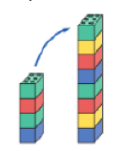  Doubling – Children will understand doubling as making a number twice as big using a range of equipment.  Double 4 is 8. | 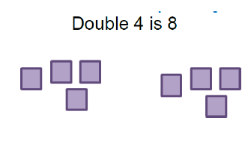  Children draw a picture to represent the objects doubled. | 4 + 4 = 8  2 x 4 = 8  Just know it! – Children will learn double facts off by heart 1-5 and then to 10.
Children begin to explore concept by grouping into equal groups.  E.g. 2 candles on each cake, pairs of socks.  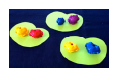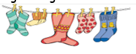  Repeated grouping/repeated addition  - × 4  - + 4 + 4  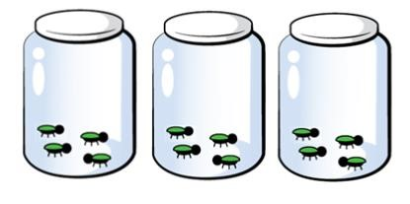  “There are 3 equal groups, with 4 in each group.” | Children to represent the practical resources in a picture and then use a bar model.  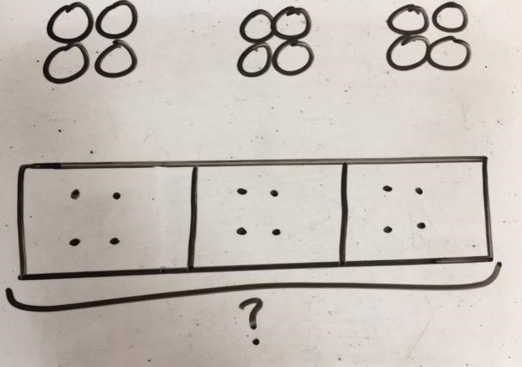 | Children to then record as repeated addition and then move onto multiplication.  4+ 4 + 4 = 12  3x 4 = 12  Just know it! – Children will begin to count in 2s, 5s and 10s and learn these by heart. Moving on to learn other x table facts.
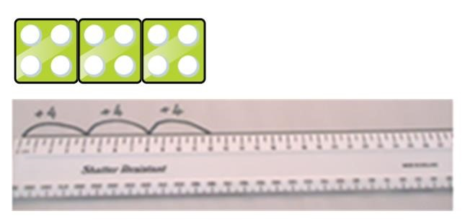  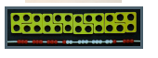  Number lines to show repeated groups- 3 × 4 Cuisenaire rods can be used too. | Represent this pictorially alongside a number line e.g.:  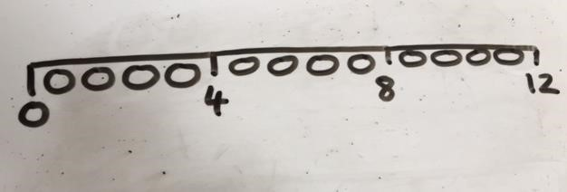 | Abstract number line showing three jumps of four.  3 × 4 = 12  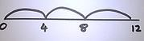  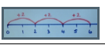  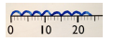

Use arrays to illustrate commutativity. Counters and other objects can also be used.  2 × 5 = 5 × 2  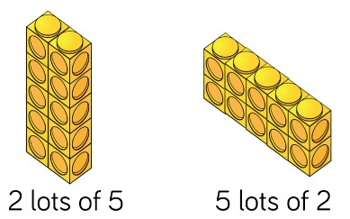  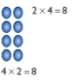  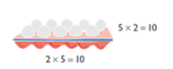  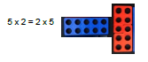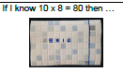 | Children to represent the arrays pictorially.  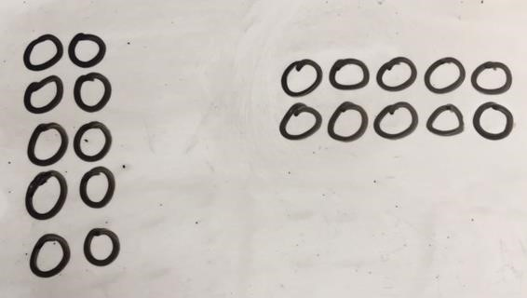 | Children to be able to use an array to write a range of calculations e.g.  10 = 2 × 5  5 × 2 = 10  2 + 2 + 2 + 2 + 2 = 10  10 = 5 + 5  If I know… Children recognise and use factor pairs and commutativity in mental calculations.
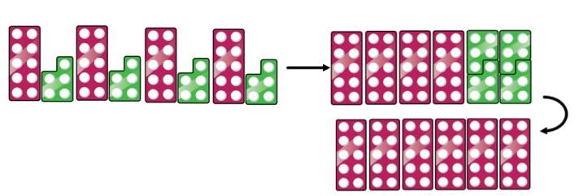  Partition to multiply using Numicon, base 10 or Cuisenaire rods. 4 × 15  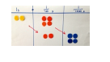  If I know 4x6 then 0.4 x 6 is ten times smaller 0.4 x 0.6 is ten times smaller again. | Children to represent the concrete manipulatives pictorially.  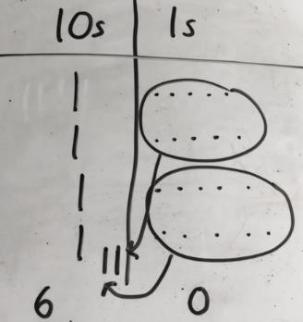  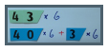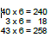  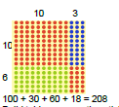 | 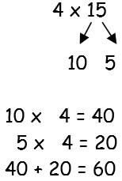  Children to be encouraged to show the steps they have taken.  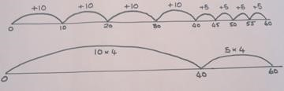  A number line can also be used  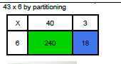  Developing mental methods  Use place value, know and derived facts to multiply and divide mentally including multiplying by 0 and 1; multiplying together three numbers. “If I know 4x6 = 24 then 40x60 is ten times bigger.”
Formal column method with place value counters  (base 10 can also be used.) 3 × 23  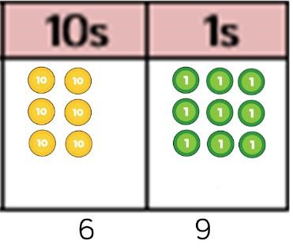 | Children to represent the counters pictorially.  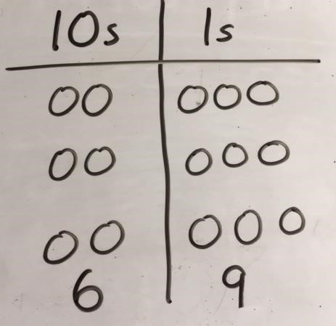 | Children to record what it is they are doing to show understanding. 3 × 23 3 × 20 = 60  3 × 3 = 9  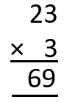  20 3 60 + 9 = 69

Formal column method with place value counters. 6 x 23  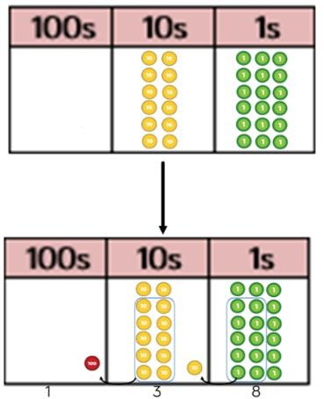 | Children to represent the counters/base 10, pictorially e.g. the image below.  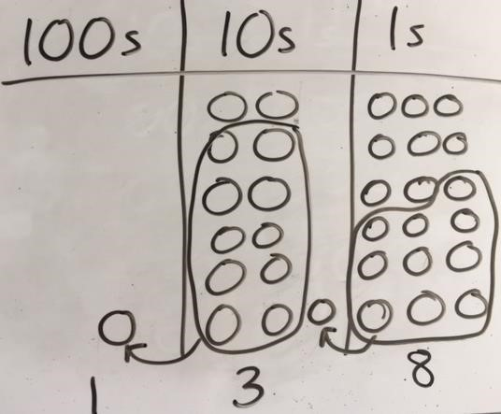 | 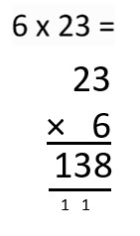  Formal written method
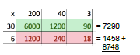
Grid method linked to formal written method.
Developing mental methods – identify multiples and factors including finding all factor pairs of a number and common factors of two numbers establish whether a number up to 100 is prime.

When children start to multiply 3d × 3d and 4d × 2d etc., they should be confident with the abstract:  To get 744 children have solved 6 × 124.  To get 2480 they have solved 20 × 124. |  | 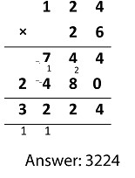
Conceptual variation; different ways to ask children to solve 6 × 23

